|  |  |  |  |  |  |
| --- | --- | --- | --- | --- | --- |
| Date | 22-Nov-22 | | | Tester Name | Richard Belanger |
| Environment | Penfax - Test | | | Login used | TEST2 |
| Operating System | Windows | Version: | Update: | | |
| Software Used | Edge | Version: | Update: | | |
| Not Applicable | Version: | Update: | | |
| Release version | 22.4.1 | | | | |
| Title | M 2.01 Update a Members Address | | | | |
| Test Type | Regression | | | | |
| Test Scenario | In PENFAX change a member’s address | | | | |
|  |  | | | | |
| Expected Results | The new address will be added and verified. It will then be the address of record | | | | |
| Pass/Fail | Pass | | | JIRA# | N/A |

Describe your steps with screenshots:

Prior to Update SID = 213733

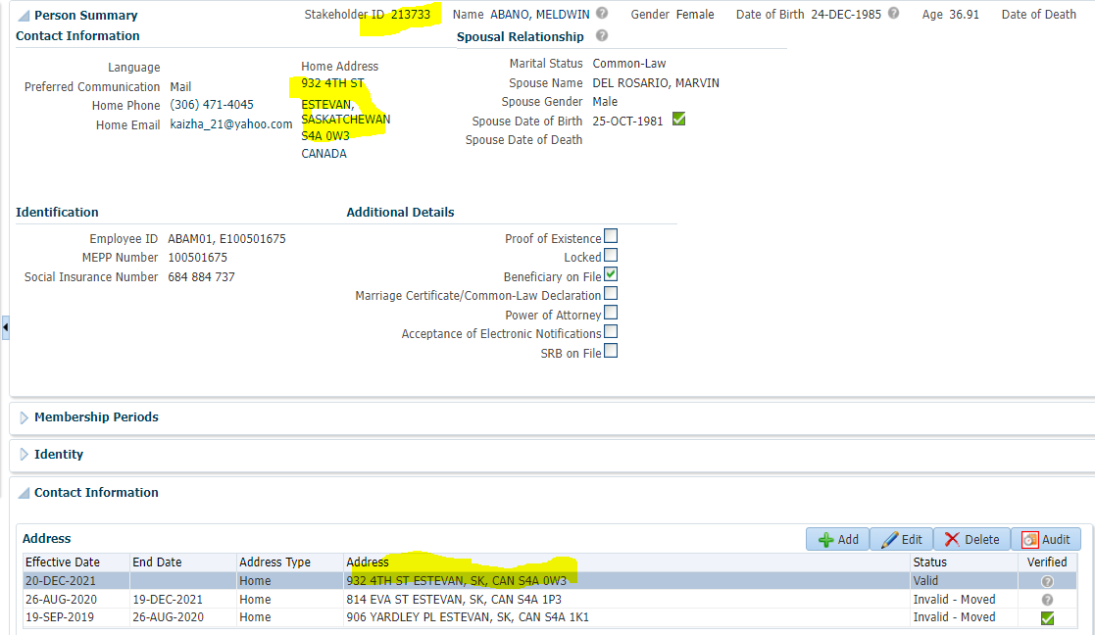

Change Member’s Address

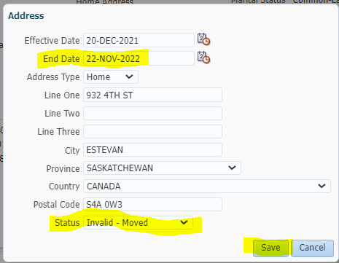

Address now Invalid-Moved-Add new Address

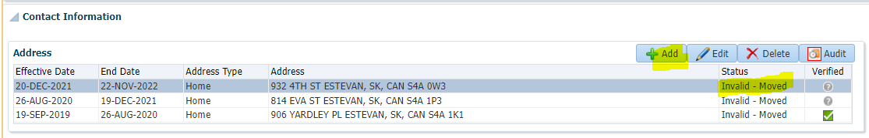

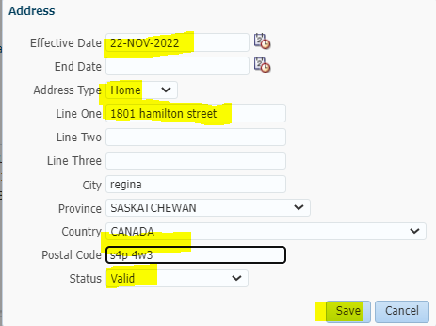

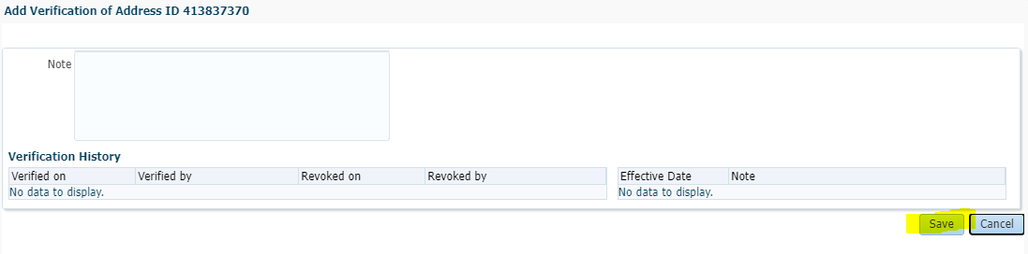

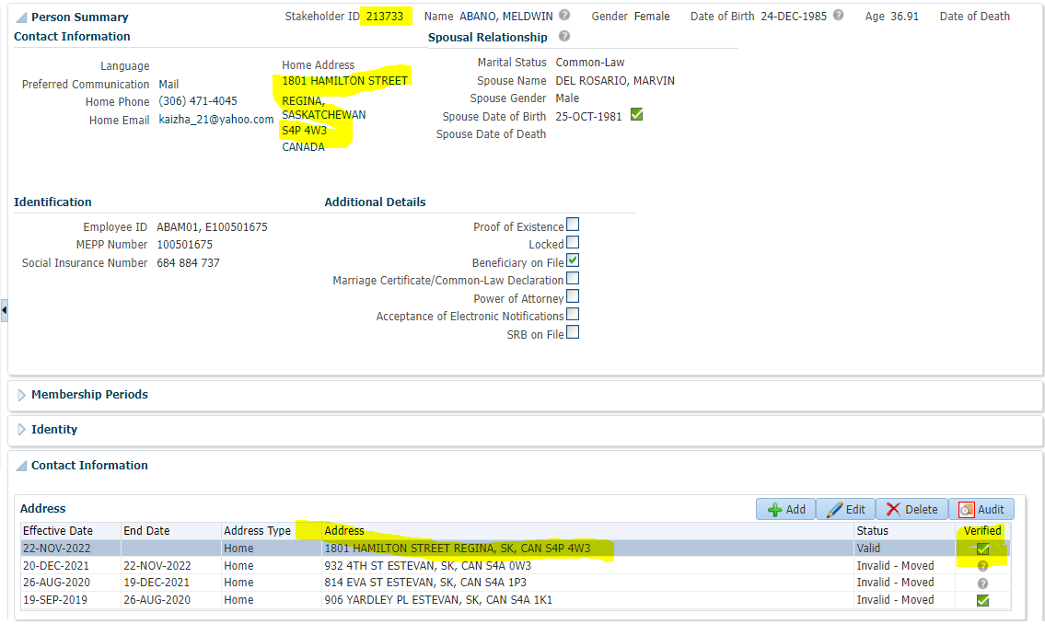

Prior to Update SID = 191303

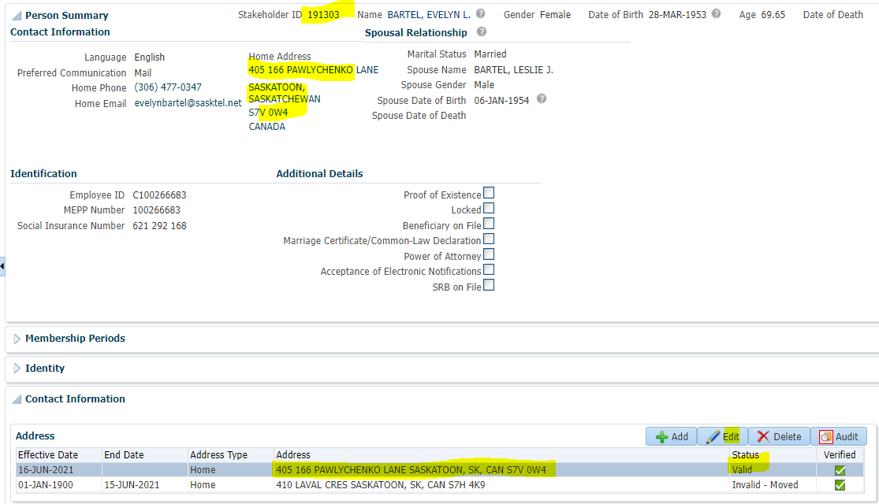

Change Member’s Address

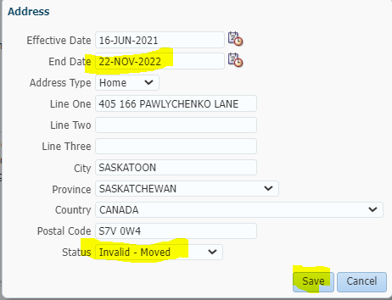

Address now Invalid-Moved-Add new Address

